**FLIGHT MANAGEMENT SYSTEM**

**Team Members:**

1. Satyam Pisal
2. Roshan Kasliwal
3. Rishabh Kulhare
4. Hrishikesh Jha
5. Dhanashree Sonaje
6. Namarata Kamble

Abstract:

The Flight Management System is a Java-based booking solution for flight tickets. It

consolidates data provided by different airline carriers and hence provides the user details

and rates in real-time. Travellers may want to make changes in their bookings. The

application allows them to book, cancel, view and update their bookings with ease. Other

than this, it eases the management of bookings too. All the bookings, flights, schedules and

routes can be viewed, added and modified on a single application by the administrator.

Class Diagram:

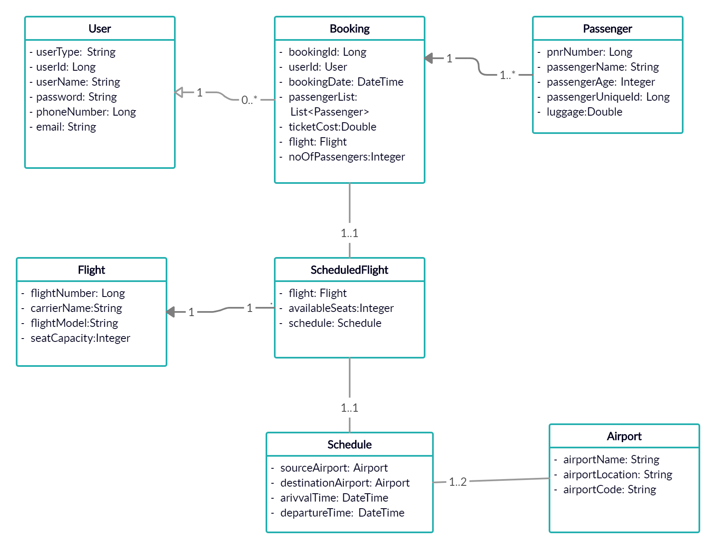

Use Case Diagram:

User Case Diagram:

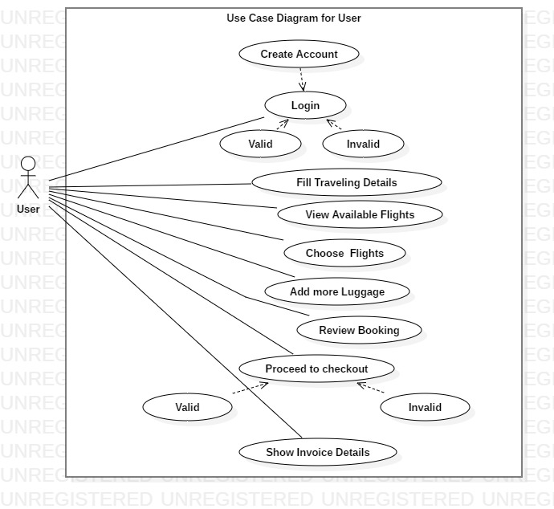

Admin Case Diagram:

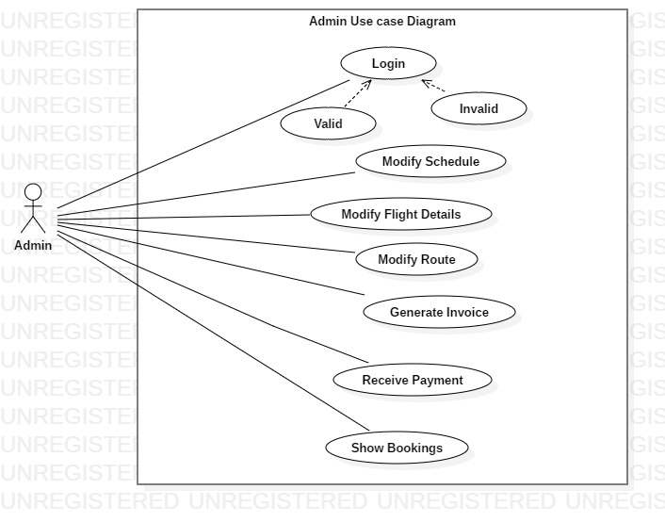

Entity Relation Diagram:

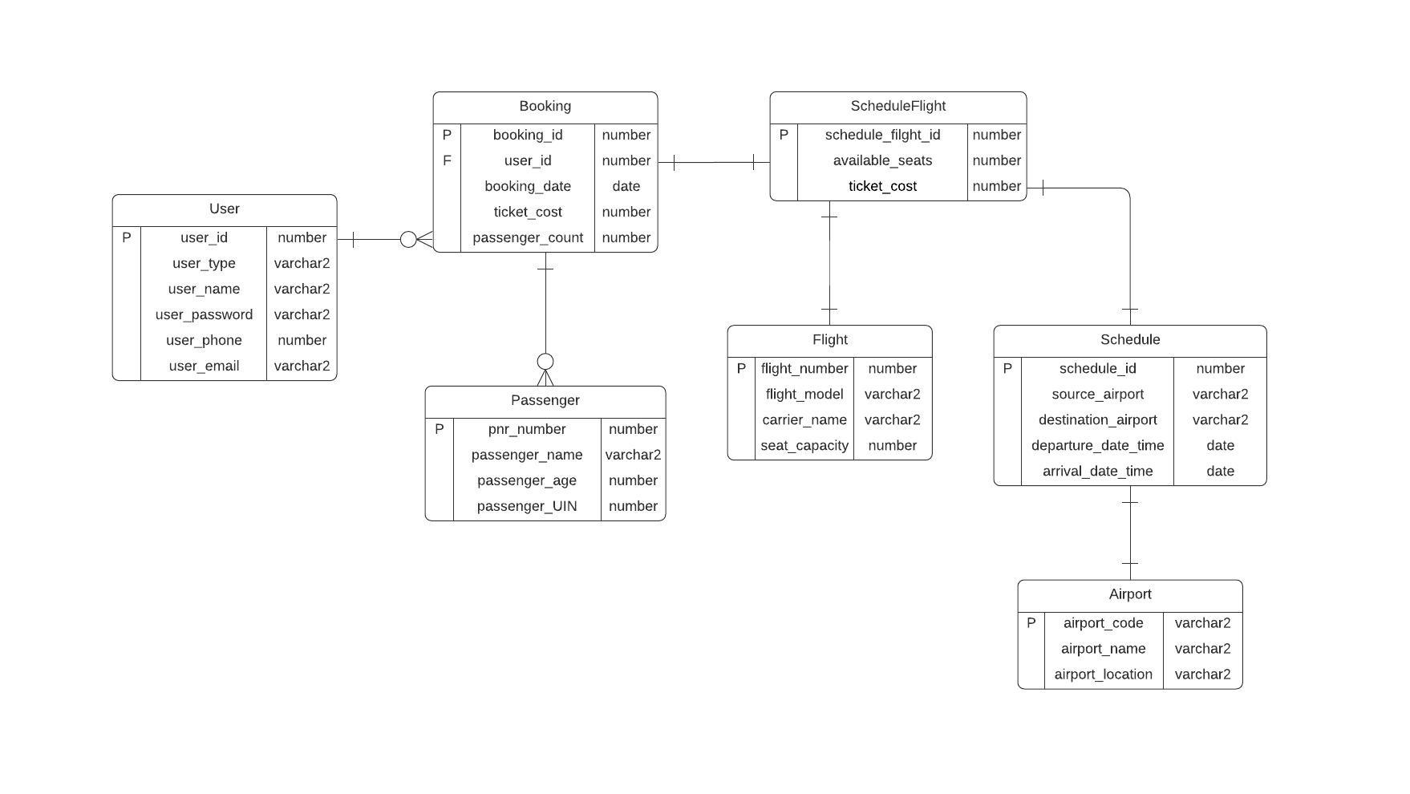

Sequence Diagram:

